 | Employment Application
  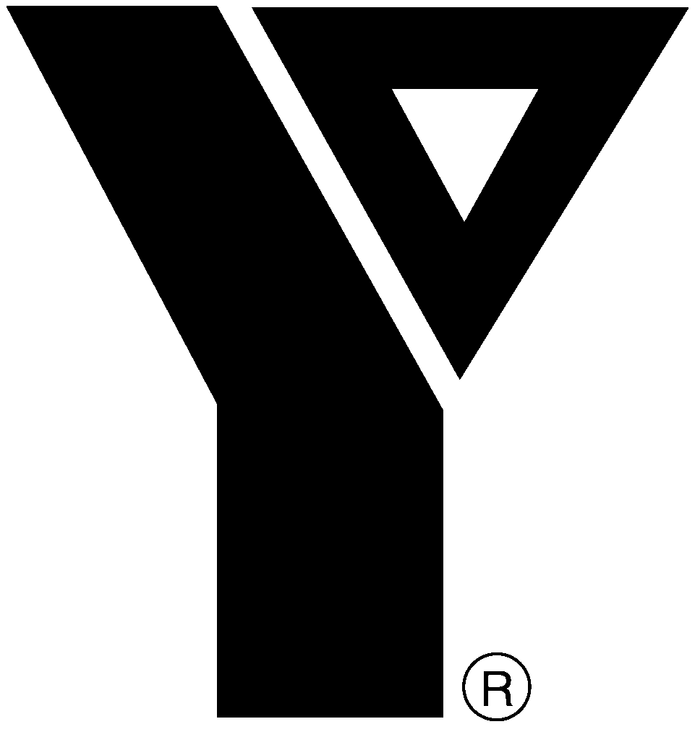 | YMCA of the Upper Main Line
   | Lionville Community YMCA
   | Upper Main Line YMCA
  We build strong kids, strong families, strong communities.

Thank you for considering employment at the YMCA. We are an Equal Opportunity Employer. Applicants for all job openings are welcome and will be considered without regard to race, color, religion, national origin, sex, age, sexual orientation, physical or mental disability, or any other basis protected by state, federal or local law.

To view a list of current job openings, go to http://www.umly.org/employment.asp. Complete this form and indicate the position you are applying for under Employment Desired. Applications without this information will not be accepted. If you are downloading this form, you may email your application to umlyhr@umly.org. Otherwise, print, sign and mail the completed form to: Human Resources, YMCA of the Upper Main Line, 1416 Berwyn-Paoli Road, Berwyn, PA 19312.

PERSONAL INFORMATION
NAME: Please PRINT or TYPE |  | Email Address
ADDRESS: Street |  |  | City |  | State | Zip Code
Can you, if hired, submit verification of your legal right to work in the U.S.? |  |  |  | Home Telephone No.
Yes No
Are you over 18? | If hired, do you have a reliable means of transportation to get to work? |  |  | Alternate Telephone No.
Yes No | Yes No
Are you related to or residing with anyone in our employ?
Yes No | If Yes, state name and branch/department:
Would you be willing to submit to pre-employment drug testing?
Yes No
Have you ever been convicted of a felony, or for child abuse or sex-related crimes? (A conviction will not necessarily disqualify you.)
Yes No | If Yes, state the name under which you were convicted, the nature of the offense, when, where, and disposition. 0
Please refer to the description for the position to which you are applying. Are you able to perform the tasks required, with or without an accommodation? Describe any tasks for which you require accommodation to perform, and what accommodation you will need.
Yes No | 0

EMPLOYMENT DESIRED |  |  | You must apply for specific job opening(s). Check the website or job postings at any of our locations.
Name of POSITION applying for: |  |  |  |  |  | Location(s):
 |  |  |  |  |  | Berwyn Lionville Eagleview
Date Available (m/d/yy) |  |  |  |  |  | Job Status desired:
 |  |  |  |  |  | Full time Part time Seasonal
Please refer to the description for the position to which you are applying. Will you be able to work the schedule described therein?
Yes No |  |  | If No, what Days/Hours you are available?
Have you ever applied to or been employed by the YMCA of the Upper Main Line?
Applied Employed |  |  | Where, when, and in what capacity?
How were you referred to us?
Newspaper, please identify: |  |  |  |  | Jobs In Pa YMCA Website Walk In
Other Source, please identify: |  |  |  |  |  | Employee Referral /Name:

EDUCATION & TRAINING
School Name and Location of School |  |  |  |  |  | No. of Yrs. Attended |  | Graduate? |  | Major (if applicable)
High School |  |  |  |  |  |  |  | Yes No
College/University |  |  |  |  |  |  |  | Yes No
College/University |  |  |  |  |  |  |  | Yes No
Highest Degree Earned (select one only): |  |  |  |  |  | Certifications (check all that apply). Enter date as m/d/yy.
High School | Associate |  |  | Bachelor 0 |  | CPR | Expires: |  | Lifesaving |  | Expires:
Master | Doctorate |  |  |  |  | First Aid | Expires: |  | Other (describe below)
Please describe ADDITIONAL SKILLS, TRAINING, VOCATIONAL, and/or PROFESSIONAL INFORMATION such as special areas of research or study, seminars, etc. in the space below. In addition, you may attach a resume or other summary information that is relevant to this application.

PREVIOUS EMPLOYMENT | Please list in order of MOST RECENT EMPLOYMENT FIRST.
Company Name |  | STARTing Job Title | FINAL Job Title
Address (City, State, Zip) |  | STARTing Pay | FINAL Pay
Supervisor (Name & Title) |  | Phone No. | Length of Service (Yrs./Mos.)
Describe your Job Duties:
Company Name |  | STARTing Job Title | FINAL Job Title
Address (City, State, Zip) |  | STARTing Pay | FINAL Pay
Supervisor (Name & Title) |  | Phone No. | Length of Service (Yrs./Mos.)
Describe your Job Duties:
Company Name |  | STARTing Job Title | FINAL Job Title
Address (City, State, Zip) |  | STARTing Pay | FINAL Pay
Supervisor (Name & Title) |  | Phone No. | Length of Service (Yrs./Mos.)
Describe your Job Duties:
May we contact the employers listed above? If No, explain which one(s) you do not wish us to contact and why. (An offer of employment is contingent on checking references with all prior employers.)
Yes No

REFERENCES | List at least 3 References (2 unrelated, 1 related to you).
Name and Occupation |  | Address | Phone No.
NOTE: The YMCA intends to conduct a background investigation and to contact any or all employers and references listed in this application.

*** Applicant: Leave Reference Verification blank. If you are mailing in this form, turn to Page 4 to complete your application. If you are submitting via email, your application is now complete. Save it to your hard drive and email as a file attachment to umlyhr@umly.org. ***

REFERENCE VERIFICATION (OFFICE USE ONLY) Write details of reference checks below. 3 positive references required for employment.
1. | Call Date: |  |  |  |  |  | Referrer’s Name:
1. | Dates of Employment:
1. | Nature of Job:
1. | Attendance Issues:
1. | Good People Skills: |  | with children | Yes No |  |  |  | Eligible for Rehire: |  | Yes No
1. |  |  | with other employees | Yes No
1. |  |  | with customers | Yes No
1. | Notes:

2. | Call Date: |  |  |  |  |  | Referrer’s Name:
2. | Dates of Employment:
2. | Nature of Job:
2. | Attendance Issues:
2. | Good People Skills: |  | with children | Yes No |  |  |  | Eligible for Rehire: |  | Yes No
2. |  |  | with other employees | Yes No
2. |  |  | with customers | Yes No
2. | Notes:

3. | Call Date: |  |  |  | Personal | Referrer’s Name:
3. | Notes:

4. | Call Date: |  |  |  | Personal | Referrer’s Name:
4. | Notes:

Supervisor: |  | Department:

CERTIFICATIONS |  |  | IF SUBMITTING VIA EMAIL, you may sign this form if and when you are called in for an interview.
I understand that this application is only valid for the position applied for at present and that the YMCA is not obligated to retain or consider this application for future openings.
 | Initial
I authorize investigation of all statements contained in this application. I understand that falsification, misrepresentation or omission of facts called for will result in immediate termination from employment or removal of my application from consideration. I authorize the YMCA to secure information about my experience with former employers, educational institutions and agencies, and for those parties to provide information concerning my experience releasing all parties from any liability arising there from.
 | Initial
If employed by the YMCA, I will abide by Association policies and rules. I understand that I will be required to possess a current and valid driver’s license with a clean driving record in accordance with Association policy if my position requires me to drive in the course of my work.
 | Initial
I agree to submit to legally permissible drug and/or alcohol testing, child abuse clearance, and police clearance checks at pre-employment and beyond that, upon request by the YMCA. I recognize that the results of these tests may be used to determine my employment or continued employment. I understand and expressly agree that if employed by the YMCA, storage areas provided for me (locker, desk, etc.) are open to investigation by the YMCA without prior notice to me.
 | Initial
If I am employed by the YMCA, I understand that it is on an “at-will” basis and that my employment can be terminated, with or without cause, and with or without notice, at any time at the option of the YMCA or myself. I understand that, other than the CEO of the YMCA, no manager, supervisor or representative of the YMCA has authority to enter into any agreement for employment for any specific period of time, or to make any agreement contrary to the foregoing or contrary to association policy. Only the CEO of the YMCA has the authority to make any agreement contrary to the foregoing and then only in writing. I further expressly agree that, with respect to the “at-will” employment relationship, this constitutes the full, complete and final expression of the parties’ intent concerning the nature of any employment relationship between the YMCA and myself.
 | Initial
My signature below certifies that I have read and understand the foregoing and to the best of my knowledge and belief, the information on this form is true and correct.

My signature below also certifies that I agree to be bound by the terms and conditions stated in this application. This application contains all the understandings and agreements between me and the YMCA concerning the nature of my employment, if any, by the YMCA and supersedes all prior and/or contemporaneous practices, oral or written agreements, understandings, statements, representations and promises, express or implied, between me and the YMCA. I understand and agree that, except as noted above, no person who is either an agent or employee of the YMCA may modify, delete, vary or contradict, whether orally or in writing, the terms and conditions set forth herein.

 |  | Applicant Signature |  |  | Date
 |  | Parent or Guardian’s Signature  (required if under 18) |  |  | Date

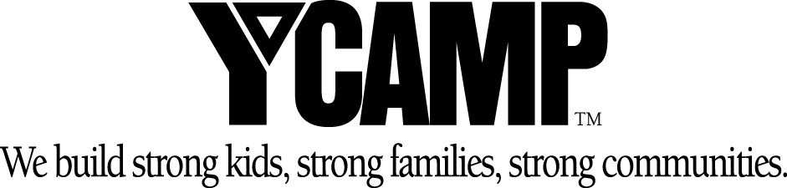
2007 SUMMER CAMPS

Lionville Community YMCA Camps

ARTS AND NATURE CAMPS | SPORTS CAMPS
Art | Basketball
Creative Explorations | Soccer
Guitar | All Sports
Piano
Hip Hop, Bake and Build
Magic and Juggling | DAY CAMP 6 to 12 years
Photography
Fishing at Marsh Creek State Park | TEEN ADVENTURE CAMP
Tracks and Trails | 13 to 15 years

Upper Main Line YMCA Camps

Totally Twos | Kindercamp | Day Camp
2 ½ years | 3 to 5 years | 6 to 12 years
SPORTS CAMPS | NATURE CAMPS | OVERNIGHT CAMPS
Basketball | Nature Safari | Adirondack Sailing Adventure
Soccer | Backyard Safari | Marine Ecology
All Sports | Tracks and Trails | Backpack Adventure
Field Hockey | Birding and Raptor
Lacrosse | Fishing | CAMP AT VALLEY FORGE
Gymnastics | Wildlife Explorer | Valley Creek Camp
In-Line Camp | Eco-Adventure | Jr. Birder Camp
Skateboard Camp
Golf | PERFORMING ARTS | ARTS/SCIENCE/COOKING
Tennis | Stage Kids | Arts & Crafts
 | Musical Theater Workshop | Art
Teen Adventure Camp | Summer Stage | Creative Explorations
13 to 15 years | Teen Music Workshop | Einsteins Science Camp
 | Tiny Dance | Little Chefs
 | Dance Camp | Kids Creative Cooking
Go to the next page to complete the Summer Employment Questionnaire.

Summer 2007 Employment Questionnaire

Name |  |  |  |  | Phone No.
At the YMCA of the Upper Main Line, we offer over 60 different camps from 2 separate branches in Berwyn and in Lionville. By answering the following questions, you will help us to determine the best fit for you.

For a list of camps, check the Camp Guide at http://www.umly.org or http://www.lionvilleymca.org.

For a list of summer jobs offered at each location, go to http://www.umly.org/employment.asp.

Position(s)  Applying For: |  |  |  |  | Referred By:

Skills/Interests: |  | Please answer the following: |  |  | Yes | No
Archery  Arts & Crafts  Baseball  Backpacking  Basketball  Canoeing  Cooking  Dance  Drama  Field Hockey  Golf  Gymnastics  In-line Skating  Music  Nature  Orienteering  Rope/Wall Climbing  Science  Skateboarding  Soccer  Swim Lessons  Tennis |  | 1. | Have you ever worked at a camp before?
 |  | 2. | Have you ever worked with children besides babysitting?
 |  | 3. | Have you ever taught swimming lessons?
 |  | 4. | Have you taken any courses related to childcare?
 |  | 5. | Age group/gender you prefer to work with:  3-5 9-12 Boys Girls  6-9 12-15
 |  | 6. | Are you willing to work with a different age group/gender as well?
 |  | 7. | Weeks you are available to work:
 |  |  | 6/4 – 6/8 (Pre)  6/11 – 6/15 (Pre)  6/18 – 6/22  6/25 - 6/29  7/2 – 7/6  7/9 – 7/13 | 7/16 – 7/20  7/23 – 7/27  7/30 – 8/3  8/6 – 8/10  8/13 – 8/17 (Post)  8/20 – 8/24 (Post)

Please complete the following:
List any other pertinent skills not mentioned above:
List 3 reasons why you want to work at our Y Camps:
1.
2.
3.
What do you feel you have to offer to our Y Camps?

